

**Ministry Category:** Ministry of Railways

**Problem Code:** #IR11

**Team Name:** Squad 6

**I4C CODE: 7893**

**Team Members:**

1. Shraddha Makwana**(TEAM LEADER)**
2. Puja Gupta
3. Bhargav Zantye
4. Kevin Rodrigues
5. Nisarg Shah
6. Shubham Shete

**TEAM MENTORS**

1. Mahendra Mehra

2. Thompson Naidu

**Problem statement : Tracking of Individual Package booked in Parcel and Luggage**

Parcel and luggage packages are booked for transport from one station to another. A receipt is issued to the consigner on depositing the package at parcel/luggage office.  At some stations where computerization of parcel office has been implemented, Barcode tags are pasted on package.

* At present, the mechanism of tracking of individual package is not available.
* Customer wants the information about current location of the package on Indian Railways system.

**Description of Idea / Solution:**

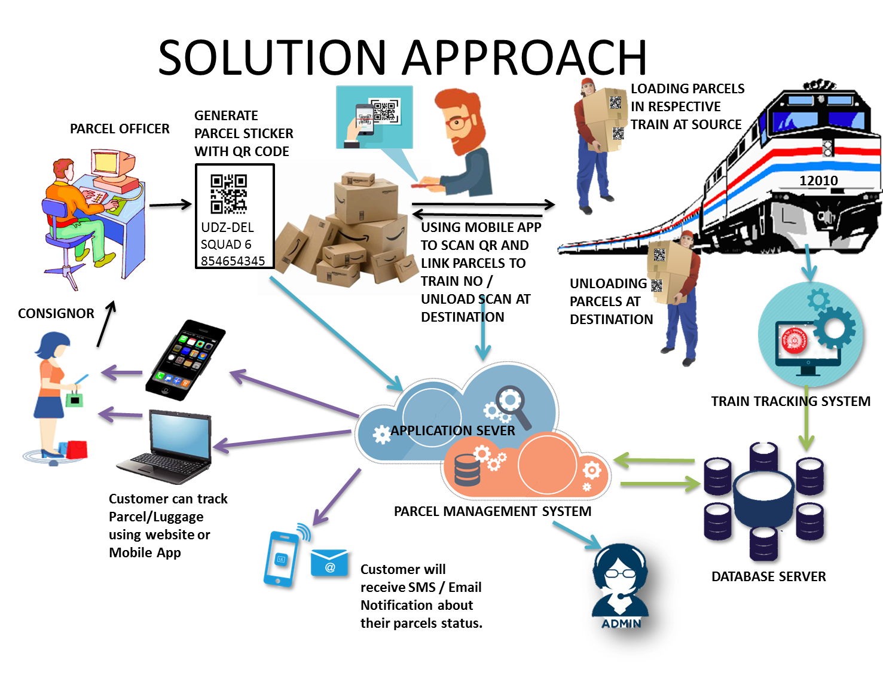

**Figure: Proposed Solution**

Our system uses QR codes that can be used in parcel tracking system for items accountability, where unique QR code is placed on each of item and operator can use code to quick check-in & check-out of the item.

In supply chain management QR code is used which tracks packages in train. When QR code is placed on shipping package, parcel officer will scan it using the mobile application we created, where he will map the parcel ID to the train on which it will be loaded using mobile application.

Once the individual parcel has been mapped to a train. We will be providing real time information like its current location on the Indian Railway system, Estimated time to reach its destination via mobile App and dedicated Website for parcel tracking.

Features like notification via Email and SMS is also available to the customers.

Offloading of parcels at wrong stations is no more a thing to worry about as our system will intimate the parcel officer about the same at the time of offloading and which can be taken care at ground level and such statuses will always show up on our tracking system.

Admin panel will help the parcel officer to keep track of all the packages on the system and make necessary changes in case of wrong updates made to the system.

**Our tracking model deals with intricacies by using following all scenarios -**

**Technology stack:**

* **Web application at each rail department –** This web module can be developed by Java/JSP servlet
* **Android Application –** Android app (Development tool would be Android Studio which is bundle that comprises of everything to develop an android app).
* **QR (Quick Response) code-** These QR codes will contain memory to store information.
* **User Side Website / mobile App–** To show tracking of package to user made by JSP/ Java or Responsive web App(cross OS support)
* To implement Location of train : **Web Scraping** / **Indian Railway API**
* **Admin portal** – PHP5, Bootstrap 3, Angular js
* **Database : MySQL 4.4.13.1deb1**
* **Webserver hosted on : Apache webserver 2.4.12, Glassfish server 4.1.1**

**Solution:**

1)**Parcel reception/QR generator web application -** This module will be used by parcel officer who take all information of consignor, consignee and package source and destination station as input and generates QR code which is to be placed on individual packages.

2) **Mobile application(load/unload module)** - Using this module we are mapping train number with individual packages. While loading the parcel officer can specify the train no and source station of package where its being loaded. which helps our system associate package with the train. Likewise unloading a package at destination just needs a scan of QR and it gets registered on the system that the package has reached its intended destination. Incase if the package is offloaded at the wrong destination the scan will prompt the officer about the mistake which can be then dealt with

3) **Railway API/Scraping** - Module will track real time location of train its time of arrival at intermediate stations and estimated time of arrival at the intended destination. This module keeps updating the table and makes appropriate changes of location on server for all loaded packages on any given train.

4) **User end tracking module(website/mobile app)** - This application shows the status of parcel to the customer like prepared, Dispatched, Intransit and Arrived to customer. Intransit section shows the complete details like train on which package is loaded its current location along with exact time to arrival and estimated delay if any. It also shows location of package on google Map

5)**Admin Portal** - used by administrator to handle entire package tracking model help him in making necessary changes if any due to wrong handling of packages.

**Description of Use Case of project:**

The model comprises of following main modules and scenarios which is demonstrated using use case diagram:

Sender

Employee at sender side hub

Package loader

Android app user

Package remover

GPS TTraTransmitterPro

Web app at each rail office

User website

Employee at receiver side hub

Receiver

The mentioned actors would be using this application as described in the above section of description of idea.

The list of actors/modules is as follows with their respective role:

* Sender – Consigner who wants to send package
* Receiver – To whom package has to be delivered.
* Employee at sender side hub – They will gather needed information, give this info to server, bill generate, barcode generate, stick this barcode on package, make package ready to ship with the help of web app
* Employee at receiver side hub – They will be responsible for delivering package to receiver.
* Android app user – The one who loads and remove packages from train will use this Android application
* GPS – It is provider of location of each train.

**Description of dependencies / Stoppers:**

* In order to make this system efficient, firstly we need Android enabled phone and if we have one then Android Application phone needs internet to update information on server.
* In order to track each train Indian railway API is needed or else as mentioned above GPS transmitter has to be there in each train.